## Company description

Bio&bio is a daughter company of Biovega. Biovega, a leader in the Croatian market of organic products, which today employs 170 people, is a business concept driven by the life passion of its founders – Zlatko Pejic and Jadranka Boban Pejic. The motive behind the establishment of the company is that the two wanted to share their lifestyle based on ecology with others and encourage positive change. The assortment started getting bigger and bigger and that is how the bio&bio came to life – a retail chain of bio product stores which nowadays consists of 16 physical and one online store. To round up the whole business story, in 2010 Biovega started to manufacture their products at the oldest Croatian eco field Zrno in Habjanovcu, and has combined the knowledge and experience of the traditional agriculture with the ecological standards in the food production. Together with Bio Zrna, there is also a bio bistro Zrno, in which they use the food grown in the fields. The whole field is dedicated to a zero waste mission, and is often used as an example of the future biological projects in Croatia.

The company was founded in 1990 with an initial share capital of 2116 Croatian Kuna (HRK). Throughout the years, their capital gradually increased, and today, their share capital is estimated at around 2.87 million HRK. In 2019, they reported an increase in sales of 6.3% (from 112 million to 119 million HRK) with earnings before interest, taxes, depreciation, and amortization of 4.1 million HRK.

Biovega is working on the distribution and market of the best quality certified organic products and works with 53 international sellers and 160 domestic sellers.

* In 2019, Biovega has shown that the most of the organic products are from Croatia, which is a way for them to show how they support the local producers;
* The quality of work and products is confirmed by inspections, and on average they have around 70 inspections which passed with no mistakes;
* After a monitoring of the system and the quality of the food by the SGS company, there were no mistakes or suggestions for improvement.

They have 3 fundamental values for their work culture and wellbeing:

1. ***Ethics*** - they treat employees, partners, and customers by respecting the law inforcements and complying with the ethics of business. They invest in the education of their employees and improve the quality of business, life and development. The average age of the employees is 37 years, and 65% of the workers are women. The average salary in 2019 was 6525HRK, and they have invested around 400 thousand HRK in the education of their employees.
2. ***Ecology*** - they encourage the eco production, recycling and the energy and resource saving.
3. ***Economy*** – they invest in the development of the business (complying with ISO and HACCP quality standards), making their business available both to customers and employees.

The goals they have completed for 2019 are:

1. Improving their leading position in the market;
2. Growing the number of customers and improving their opinions;
3. Improving employees' opinions.

*„We have reached these goals by keeping our authenticity, improving our market activities, investing in education, continuing to work on the control and expenses reduction, the result was finishing the plan and improving our finances.“*

* ***Annual report of BioVega, 2019***

The main risks the company has mentioned are:

* Market risks: currency risk, interest rate risk and market liquidity risk
  1. Currency risk: The company is exposed to the risk of changes in foreign exchange rates. Their primary currency is EUR. The business risk in foreign currencies arises from recognized assets and liabilities. Receivables whose have their source in financing denominated in EUR, are secured against the risk of a sudden change in foreign exchange rates through contracts containing a currency clause. That's how the risk of changes in the exchange rate is minimized.
* Credit risk - The company has made deals with local banks that improve the need for liquidity.
* Liquidity risk - Market liquidity risk is the risk of uncollected receivables from customers, which can be reflected in the quality of serving their obligations. Given the contractual terms and internal procedures, they require continuous partner analysis, business monitoring, and insurance through payment instruments, so that the liquidity risk is reduced.
* Operational risk - The company's operating risk represents the risk of loss that may arise as a consequence of inappropriate or ineffective internal procedures, the human factor or external events. As part of operational risk management, there is a system for monitoring potential and recognizing operational risks.
* Personnel risk – the personnel risk is the fluctuation of employees in the company. The goal stabilization teams are continuously working to improve working conditions through education and rewarding.

## Cost-benefit analysis

A cost-benefit analysis is a systematic process that businesses use to analyze which decisions to make and which to forgo. The cost benefit analyst sums the potential rewards expected from a situation or action and then subtracts the total costs associated with taking that action. Some consultants or analysts also build models to assign a dollar value on intangible items, such as the benefits and costs associated with living in a certain town. (Mindtools, 2016)

* Given an estimated hourly rate of **1000 Danish Krones** (DKK) (approx. 1010 HRK) and time for programming the solution of **120-130 hours**, we estimate that this project may cost around **121-131 thousand HRK**. It is a good idea for the company to perform a cost-benefit analysis with the inclusion of the costs for developing software for the company by outside programmers hired for this task, so that they have a more precise estimate of their new expenses regarding the development itself, and the revenue the company is expecting to gain after the improved software. The company expects the following benefits from the new system:
* Improved employee experience 🡪 increased productivity;
* Increased customer interest towards the products offered by the company 🡪 increased market share;
* Better customer experience brought about by the better and easier to use software à increased popularity and, respectively, profit.

A further step of the cost-benefit analysis would be to assign a monetary value to the company’s costs, which we already did, as well as to its benefits. These are trickier to calculate and, in the company’s own word, they’re unable to provide us with an estimate of the monetary value of the benefits they’re planning to gain through the new software. Some of the intangible (soft) benefits would be:

* Smaller environmental footprint – positive impact on the environment in the long term
* Supporting local producers/farmers
* Increased employee satisfaction – thanks to the new software, customer interests would be easier to track and it would also enable improved data analysis. This could potentially lead to reduced working hours and thus, an elevation in employee satisfaction.

## Supply chain management (SCM)

**Supply Chain Management (SCM)** is the coordination/management of all supply activities (production, services, information etc.) of an organization from its suppliers and partners to its customers. (Kondylis & Mertz, Supply Chain Management, 2021) In a company, the supply chain manager should take care of planning and strategies, the sources of raw materials, deliveries, the efficiency of manufacturing and the return system (e.g., for defective materials). Things to keep in mind when organizing the supply chain management would be, for instance, ways to minimize costs along the way and reduce the food waste when supplying the company with products. The process components of Supply Chain Management are:

1. Plan – contacting local producers or providers that could supply raw materials;
2. Source – bio farms and certified Croatian organic producers;
3. Make – the actual manufacturing process during which the organic products are brought to life;
4. Deliver – sending them across stores or warehousing them and preparing for delivery;
5. Return – monitoring the produce for defective products and having a return mechanism at ready.

### Value chain analysis

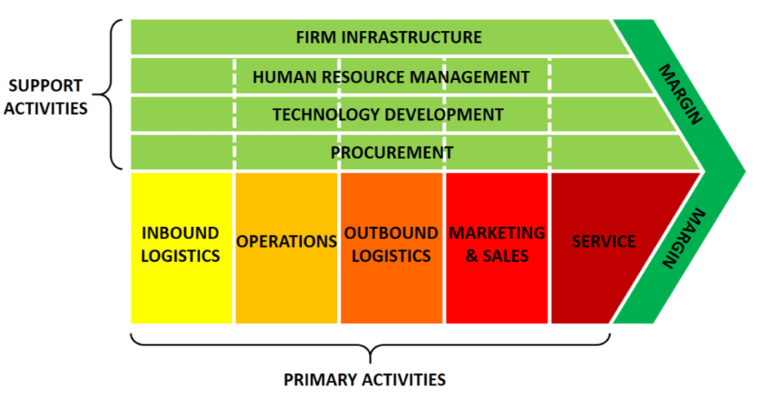

*“The idea of the value chain is based on the process view of organizations, the idea of seeing a manufacturing (or service) organization as a system, made up of subsystems each with inputs, transformation processes and outputs. Inputs, transformation processes, and outputs involve the acquisition and consumption of resources – money, labor, materials, equipment, buildings, land, administration, and management. How value chain activities are carried out determines costs and affects profits.”*

***-*** (Porter, 1985; Rowe, 1994)

* **The inbound logistics** of the company refer to company-appointed buyers who select the organic crops which are to be used in the production process.
* **Operations –** the company operates on the Croatian market through company-operated stores.
* **Outbound logistics** are not a key part of the business as the company doesn’t focus on selling to retail stores.
* In terms of **marketing and sales,** the company invests more in quality product, but also relies on online marketing to distribute its products and popularize itself.
* **Service –** the high-quality customer service and loyalty obtained in the physical stores as well as online delivery is of high value to the company.
* **Infrastructure** - this includes departments like management, finance, legal, etc., which are required to keep the company’s stores operational. The company has its management department in its main office, while on-site it employs friendly employees with broad knowledge in the field of organic nutrition.
* **Human resource management –** the company keeps a low turnover of employees and organizes many trainings and seminars to keep their motivation and skill levels high.
* **Technology development –** the company implements only high-functioning technology when manufacturing the organic products, it sells and it’s currently investing in a better, customer-and-employee-friendlier software and better website interface.
* **Procurement –** the company is entirely responsible for the supply of raw materials itself. ERP & CRM

## ERP & CRM

**Enterprise resource planning (ERP)** is a business process management software that allows an organization to use a system of integrated applications to manage the business and automate many back-office functions related to technology, services, and human resources. (Kondylis & Mertz, E-business ERP and CRM, 2021) The benefits of an ERP system come from having a single, shared database for all financial and operational data. This greatly impacts reporting — both static monthly reports and ad hoc reports requested by leadership. A single source of financial and operational data also means employees can drill down into reports to uncover financial insights without the need for IT or finance teams to conduct the analysis and reporting. This allows businesses to make faster, data-backed decisions that can impact everything from profitability to new growth opportunities to creating efficiency across the organization. (Beal, 2020)

**Customer relationship management** (CRM) is a process in which a business or other organization administers its interactions with customers, typically using data analysis to study large amounts of information. (Bardicchia, 2020) The central promise of CRM is to give the business a central repository of all customer data, tracking all customer interactions. Armed with this information and using analytics, businesses can make more informed decisions on which customers to pursue for added revenue, how sales teams are performing, how to service customers efficiently and appropriately, and more. (Beal, 2020)

A CRM is more fitting for this type of company because it's not a big enterprise, but a business which relies heavily on its direct contact with customers. Therefore, a method called “value for money” would be the most effective in this case as part of the CRM system. It consists of convincing the customer that they're being offered the best possible quality on the market for the value they're willing to pay. Furthermore, this system allows to track down customer analytics and identify potential loyal customers who would generate revenue and use the methods of “customer binding” to attract them.

*“However, our main asset is the bio&bio employees who approach each customer individually, passing on their knowledge of healthy and natural nutrition, which is the result of continuous education and personal experience.”*

* ***bio&bio.hr***

## E-commerce and online marketing

eCommerce refers to any form of business transaction conducted online. The most popular example of eCommerce is online shopping, which is defined as buying and selling of goods via the internet on any device. However, eCommerce can also entail other types of activities, such as online auctions, payment gateways, online ticketing, and internet banking. (Oberlo, n.d.)

The company we’re working with has chosen to rely on online marketing for the most part, especially given the COVID situation around the world, opting for a safer and faster approach to reach their clients. We recommended them the following types of online marketing:

1. **Social media advertising –** through relevant ads on social media such as Facebook and Instagram, potential customers could get a glimpse of the products offered; the company could benefit from this type of advertising because the products are mostly aimed at a health-conscious target group which is expected to use social media and Internet sources on healthy eating and nutrition. Another way to use this method would be working with affiliates and influencers by paying them to have their product advertised on the following persons’ social media pages.
2. **Cookie tracking** – by tracking the search history, ads could be shown to potential customers who could be interested in the company’s products. By following customer analytics, businesses could build a loyal customer network and specify their ads to be more relevant to users.
3. **SEO & SEM** - SEO is a method of ranking a website on the organic search results, which requires a high advertising budget and relatively big website popularity. Whenever clients are looking for similar products to the ones that the company sells, they use keywords on search engines such as Google, which brings out a certain number of search results, but SEM focuses on a pay-per-click approach and displays the advertisement of the company *above* the search results, which could catch the attention of interested customers.
4. **Affiliate marketing -** Affiliate marketing is the process by which an affiliate earns a commission for marketing another person’s or company’s products. (Enfroy, n.d.) In the case of the company we’re working with, they could use this method to advertise the products of the umbrella company they originated from (BioVega) and make profit.

## SWOT analysis & TOWS matrix

A SWOT analysis is a compilation of your company's strengths, weaknesses, opportunities, and threats. The primary objective of a SWOT analysis is to help organizations develop a full awareness of all the factors involved in making a business decision. (Schooley, 2019) The table shown on the next page displays a SWOT analysis of the company, as well as a TOWS matrix, used to match the environmental threats and opportunities with the company's weaknesses and especially its strengths.

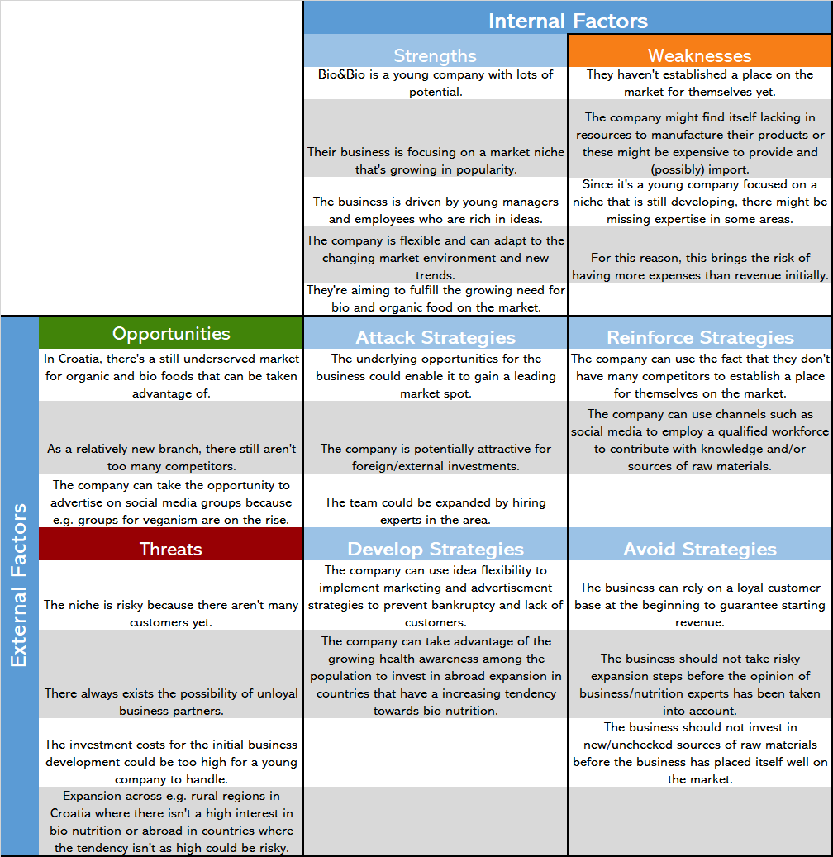

# References

Bardicchia, M. (2020). *Digital CRM: Strategies and Emerging Trends: Building Customer Relationship in the Digital Era.*

Beal, B. (2020, August 12). *CRM vs ERP: What’s the Difference?* Retrieved from NetSuite: https://www.netsuite.com/portal/resource/articles/erp/erp-vs-crm.shtml

Enfroy, A. (n.d.). *Affiliate Marketing in 2021: What It Is and How You Can Get Started*. Retrieved from BigCommerce: https://www.bigcommerce.com/blog/affiliate-marketing

Kondylis, D., & Mertz, A. C. (2021, March 25). E-business ERP and CRM. Aalborg, Nordjylland, Denmark: UCN.

Kondylis, D., & Mertz, A. C. (2021, February 11). Supply Chain Management. Aalborg, Nordjylland, Denmark: UCN.

Mindtools. (2016). *Cost-Benefit Analysis: Deciding, Quantitatively, Whether to Go Ahead*. Retrieved from mindtools.com: https://www.mindtools.com/pages/article/newTED_08.htm

Oberlo. (n.d.). *What is eCommerce?* Retrieved from Oberlo: https://www.oberlo.com/ecommerce-wiki/ecommerce

Porter, M. E. (1985). *Competitive Advantage.* New York: The Free Press.

Rowe, M. D. (1994). *Strategic Management: a methodological approach.* Addison-Wesley.

Schooley, S. (2019, June 23). *SWOT Analysis: What It Is and When to Use It*. Retrieved from Business News Daily: https://www.businessnewsdaily.com/4245-swot-analysis.html